# How to get Started with your device

## IOTAppStory Loader

The IOTAppStoryLoader is a “starter” sketch / app which connects your device to IOTAppStory.com You will have to upload this by serial connection to every new device you want to use it with IOTappStory.com. After this initial upload, future uploads will go “over the air”, because all IOTappStory.com compatible apps have the ability to connect to the platform and download a new firmware.

There are two possibilities for uploading the loader sketch.

* Flash the bin file directly with E[sptool](https://github.com/espressif/esptool) (<https://github.com/espressif/esptool>) or, for windows users, [esp8266_flasher.exe](http://www.xess.com/blog/esp8266-reflash/).
* [Compile](http://iotappstory.com/wiki/advanced/compile-loader) and upload the InitialLoader.ino. To use this method, you have to patch your Arduino IDE first **(🡪Patch the Arduino IDE.doc**).

Here, we will use the first method.

We assume you have some previous experience with programming ESPs and know how to set your board up for flashing new firmware.

## Find the com port of your device

Connect your ESP device to your computer and open the Arduino IDE. Here, you find the COM port to which your device is connected. Note it down.

## Download the tools

Download the IOTAppStory.com files from Github (https://github.com/SensorsIot/IOTAppstory.com). Included in these files is a folder called IOTAppStoryLoader:

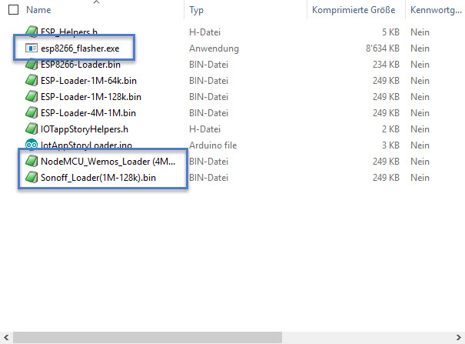

Here, you find the [esp8266_flasher.exe](http://www.xess.com/blog/esp8266-reflash/) and two .bin files. All other files are not used in this tutorial. Start this exe file and select the respective loader file:

* NodeMCU_Wemos_loader for your 4M boards
* Sonoff_Loader for your 1M boards

Enter your port from before

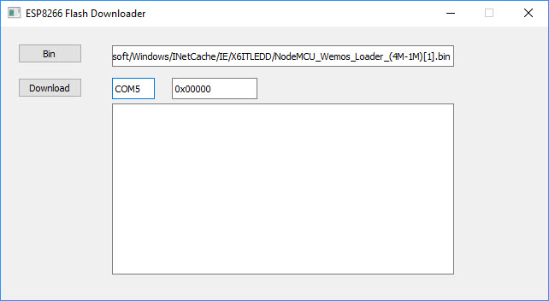

Now, you have to bring your ESP in flashing mode (also the NodeMCU and Wemos boards!!!). This is done, by pressing the reset and Flash button together, release the reset button, and release the flash button. For Wemos boards, you have to add a button to pin D3 because it has no flash button.

Now, you can hit “download” and watch the device downmoad the Firmware to your device:

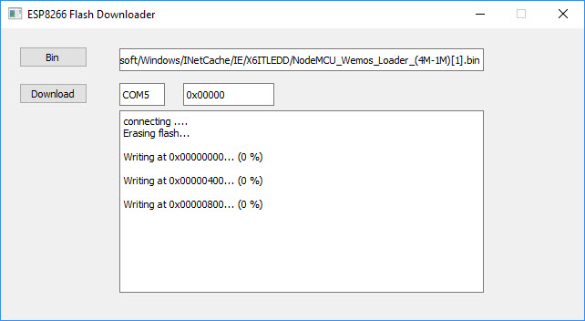

The flashing usually ends with an error message. You can ignore it.

Make sure, you reset the board once the firmware is flashed. Otherwise you will get later-on a “wdt reset” message and your ESP will be blocked. If this happens, reset it then and wait for 20 seconds at least.

Now, your ESP prints its MAC address and creates an Access point with the name “InitLoader_XX_XX_XX, where XX_XX_XX are the three last digits of the MAC address of your device. Note the MAC address down and connect with your smartphone to the WLAN. A splash screen should pop up. If not, enter address 192.168.4.1 into the browser and you will see the following picture:

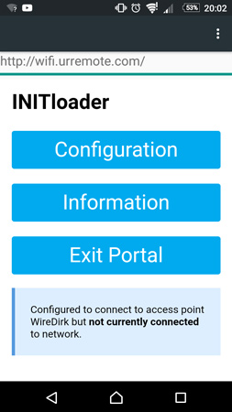

Select configuration, enter the credentials of your Wi-Fi and a new board name. The other fields are already set to connect to IOTappStory.com. Hit “save”

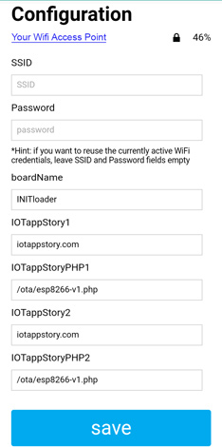

and **wait for at least 15 seconds.** Then, select “how it went”

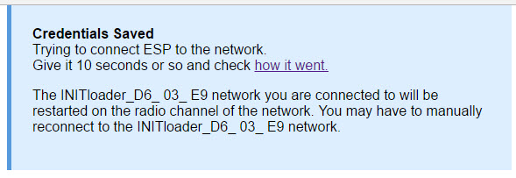

Check, if your device is connected to Wi-Fi and hit “Exit Portal”. The values are only saved now. If you do not find a IP address, you have to enter your credentials again.

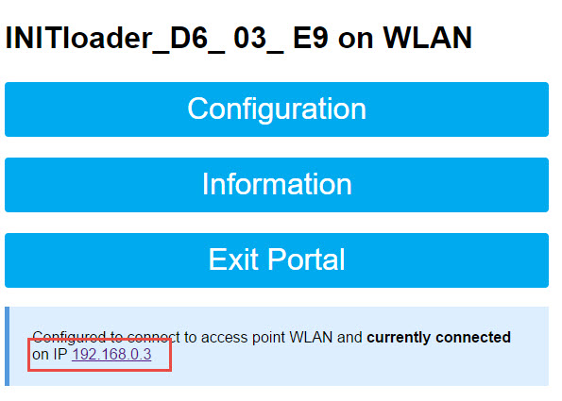

Now, your ESP should connect to IOTappsStory.com and download your project.

If you did not yet prepare a project, you will get a notification in your Serial Monitor:

